LAPORAN PRAKTIKUM
Aplikasi Berbasis Platform

Tugas 1-7


Disusun oleh:
NAUFAL GERALDO PUTRA P.
2311102154
S1 IF-11-04

Dosen Pengampu:
Cahyo Prihantoro, S.Kom., M.Eng

PROGRAM STUDI S1 INFORMATIKA
FAKULTAS INFORMATIKA
INSTITUT TEKNOLOGI TELKOM PURWOKERTO
2026
LATIHAN KELAS – GUIDED
Link Github: https://github.com/NGZ101/Laporan-Tugas-1--7-ABP

- Soal CV
- Index.html
<!DOCTYPE html>
<html lang="en">
<head>
<meta charset="UTF-8">
<meta name="viewport" content="width=device-width, initial-scale=1.0">
<title>CV NGZ</title>
<link rel="stylesheet" href="style.css">
<script src="https://kit.fontawesome.com/791ffebf52.js" crossorigin="anonymous"></script>
</head>
<body>
<div class="bg"></div>
<div class="content">

<div class="cv-card">

<div class="cv-header">
<img src="Pas Photo Naufal.jpg" alt="Foto Profil" class="profile-img">
<div class="text-container">
<table class="info-table">
<tr>
<td><b>Naufal Geraldo Putra Pramudianartono</b></td>
</tr>
<tr>
<td>Computer Science Undergraduate</td>
</tr>
<tr>
<td>+62 81289492745 | naufal.geraldo30@gmail.com</td>
</tr>
<tr>
<td>http://www.linkedin.com/in/naufal-geraldo | https://github.com/NGZ101</td>
</tr>
</table>
</div>
</div>

<div class="footer-bar"></div>

<div id="cv-data-container" class="cv-data">
<p id="loading-text">Memuat data CV...</p>
</div>

</div>
</div>

<script src="function.js?v=1.1"></script>
</body>
</html>

- Style.css
body {
margin: 0;
font-family: serif;
}

.bg {
position: fixed;
top: 0;
left: 0;
width: 100%;
height: 100%;
background-color: gray;
background-size: cover;
background-position: center;
z-index: -1;
}

.content {
position: relative;
z-index: 1;
padding: 20px;
}

/*Background Putih CV*/
.cv-card {
background-color: white;
max-width: 850px;
margin: 40px auto;
padding: 40px;
border-radius: 20px;
box-shadow: 0 8px 16px rgba(0, 0, 0, 0.1);
color: black;
}

/*Header CV (Foto & Teks)*/
.cv-header {
display: flex;
align-items: center;
gap: 30px;
}

.profile-img {
width: 150px;
height: 200px;
object-fit: cover;
border-radius: 50%;
border: 3px solid black;
flex-shrink: 0;
}

.text-container {
display: flex;
flex-direction: column;
justify-content: center;
}

.info-table {
margin: 0;
font-size: 18px;
border-collapse: collapse;
}

.info-table td {
padding: 6px 0;
}

.footer-bar {
width: 100%;
height: 8px;
background-color: #222;
margin: 30px 0;
border-radius: 5px;
}

/*Data dari PHP*/
.cv-data {
text-align: left;
line-height: 1.6;
}

.cv-data h3 {
font-size: 20px;
border-bottom: 1px solid #000;
padding-bottom: 5px;
margin-bottom: 10px;
margin-top: 25px;
}

.cv-data ul {
padding-left: 20px;
margin-bottom: 20px;
}

.cv-data li {
margin-bottom: 6px;
}

.exp-header {
display: flex;
justify-content: space-between;
align-items: baseline;
font-weight: bold;
margin-top: 15px;
margin-bottom: 5px;
}

.exp-title {
font-size: 16px;
}

.exp-period {
font-size: 16px;
text-align: right;
}

- Cv.php
<?php
header('Content-Type: application/json');

// Data CV
$data = [
"skills" => [
"HTML and CSS",
"JS using Node.js / Express.js",
"PHP using Laravel",
"SQL using MySQL and phpMyAdmin",
"Python",
"Native Level Indonesian & English"
],
"experience" => [
[
"period" => "April - December 2025",
"title" => "BEM KEMA Telkom University Purwokerto | Department of Home Affairs Intern",
"responsibilities" => [
"Communicated with other organization on campus and hear out all their problems and suggestions",
"Noted all the suggestions made by the members of organizations and forwarded it to campus authority in charge of campus organizations",
"Established relationships with staff of other campus organizations"
]
]
]
];

// Mengubah array PHP menjadi format JSON agar bisa dibaca JavaScript
echo json_encode($data);
?>

- Function.js
//Menjalankan fungsi secara otomatis saat halaman web selesai dimuat
document.addEventListener("DOMContentLoaded", function() {

//Tangkap elemen penampung data di HTML
const cvContainer = document.getElementById('cv-data-container');

//Mencegah cache browser agar selalu mengambil data JSON terbaru
const noCacheUrl = 'cv.php?t=' + new Date().getTime();

//Melakukan request AJAX
fetch(noCacheUrl)
.then(response => {
if (!response.ok) {
throw new Error('Gagal terhubung ke server');
}
return response.json();
})
.then(data => {
let htmlContent = ``;

//Skills
htmlContent += `<h3>Skills & abilities</h3><ul>`;
data.skills.forEach(skill => {
htmlContent += `<li>${skill}</li>`;
});
htmlContent += `</ul>`;

//Experience
htmlContent += `<h3>Experience</h3>`;
data.experience.forEach(exp => {
htmlContent += `
<div class="exp-item">
<div class="exp-header">
<span class="exp-title">${exp.title}</span>
<span class="exp-period">${exp.period}</span>
</div>
<ul>
`;
exp.responsibilities.forEach(task => {
htmlContent += `<li>${task}</li>`;
});
htmlContent += `</ul></div>`;
});

//Tampilan
cvContainer.innerHTML = htmlContent;
})
.catch(error => {
console.error('Error:', error);
cvContainer.innerHTML = `<p style="color: red; text-align: center;">Gagal memuat data CV dari server.</p>`;
});
});

- Hasil
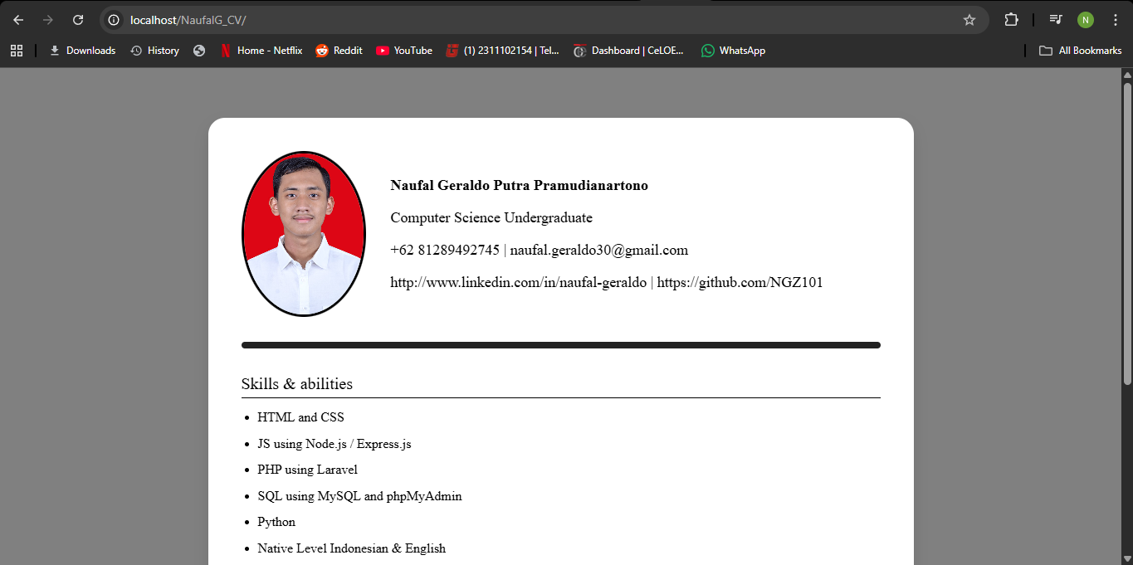
- Soal Web Profile
- ProfileController.php
<?php

namespace App\Http\Controllers;

use Illuminate\Http\Request;

class profileController extends Controller
{
public function index()
{
$data = [
"skills" => [
"HTML and CSS",
"JS using Node.js / Express.js",
"PHP using Laravel",
"Python",
"Native Level Indonesian & English"
],
"experience" => [
[
"period" => "April - December 2025",
"title" => "BEM KEMA Telkom University Purwokerto | Department of Home Affairs Intern",
"responsibilities" => [
"Communicated with other organization on campus and hear out all their problems and suggestions",
"Noted all the suggestions made by the members of organizations and forwarded it to campus authority in charge of campus organizations",
"Established relationships with staff of other campus organizations"
]
]
]
];

// Ubah array ke JSON dan cetak
return view('profile', $data);
}
}

- Web.php
<?php

use Illuminate\Support\Facades\Route;
use App\Http\Controllers\profileController;

Route::get('/1', function () {
return view('welcome');
});

Route::get('/', [profileController::class, 'index']);

- Profile.blade.php
<!DOCTYPE html>
<html lang="en">

<head>
<meta charset="UTF-8">
<meta name="viewport" content="width=device-width, initial-scale=1.0">
<title>CV NGZ</title>
<link rel="stylesheet" href="{{ asset('css/style.css') }}">
<script src="https://kit.fontawesome.com/791ffebf52.js" crossorigin="anonymous"></script>
</head>

<body>
<div class="bg" style="background-image: url('{{ asset('images/office.jpg') }}');"></div>
<div class="content">
<div class="icons">
<div class="icon-brand">
<i class="fa-brands fa-neos"></i>
<p>NGZ</p>
</div>
<a href="http://www.linkedin.com/in/naufal-geraldo" class="icon-linkedin">
<i class="fa-brands fa-linkedin"></i>
<p>LinkedIn</p>
</a>
<a href="https://github.com/NGZ101" class="icon-github">
<i class="fa-brands fa-github"></i>
<p>Github</p>
</a>
</div>

<div class="cv-card">

<div class="cv-header">
<img src="{{asset('images/Pas Photo Naufal.jpg')}}" alt="Foto Profil" class="profile-img">
<div class="text-container">
<table class="info-table">
<tr>
<td><b>Naufal Geraldo Putra Pramudianartono</b></td>
</tr>
<tr>
<td>Computer Science Undergraduate</td>
</tr>
<tr>
<td>+62 81289492745 | naufal.geraldo30@gmail.com</td>
</tr>
</table>
</div>
</div>

<div class="footer-bar"></div>

<div class="cv-data-left">

<h3>Skills & abilities</h3>
<ul>
@foreach($skills as $skill)
<li>{{ $skill }}</li>
@endforeach
</ul>

<h3>Experience</h3>
@foreach($experience as $exp)
<div class="exp-item">
<div class="exp-header">
<span class="exp-title">{{ $exp['title'] }}</span>
<span class="exp-period">{{ $exp['period'] }}</span>
</div>
<ul>
@foreach($exp['responsibilities'] as $task)
<li>{{ $task }}</li>
@endforeach
</ul>
</div>
@endforeach

</div>

</div>
</div>
</body>

</html>

- Style.css
body {
margin: 0;
font-family: serif;
}

.bg {
position: fixed;
top: 0;
left: 0;
width: 100%;
height: 100%;
background-size: cover;
background-position: center;
z-index: -1;
}

.content {
position: relative;
z-index: 1;
padding: 20px;
}

.icons {
display: flex;
gap: 8px;
}

/*Logo NGZ*/
.icon-brand {
width: fit-content;
background-color: white;
margin: 10px 0;
display: flex;
align-items: center;
gap: 5px;
padding: 5px 15px;
border-radius: 10px;
font-family: sans-serif;
}

.icon-brand i {
font-size: 35px;
}

.icon-brand p {
font-size: 20px;
font-weight: bold;
margin: 0;
}

/*Logo LinkedIn*/
.icon-linkedin {
width: fit-content;
background-color: white;
margin: 10px 0;
display: flex;
align-items: center;
gap: 5px;
padding: 5px 15px;
border-radius: 10px;
font-family: sans-serif;
}

.icon-linkedin i {
font-size: 35px;
}

.icon-linkedin p {
font-size: 20px;
font-weight: bold;
margin: 0;
}

/*Logo Github*/
.icon-github {
width: fit-content;
background-color: white;
margin: 10px 0;
display: flex;
align-items: center;
gap: 5px;
padding: 5px 15px;
border-radius: 10px;
font-family: sans-serif;
}

.icon-github i {
font-size: 35px;
}

.icon-github p {
font-size: 20px;
font-weight: bold;
margin: 0;
}

/*Background Putih CV*/
.cv-card {
background-color: white;
max-width: 850px;
margin: 40px auto;
padding: 40px;
border-radius: 20px;
box-shadow: 0 8px 16px rgba(0, 0, 0, 0.1);
color: black;
}

/*Header CV (Foto & Teks)*/
.cv-header {
display: flex;
align-items: center;
gap: 30px;
}

.profile-img {
width: 150px;
height: 200px;
object-fit: cover;
border-radius: 50%;
border: 3px solid black;
flex-shrink: 0;
}

.text-container {
display: flex;
flex-direction: column;
justify-content: center;
}

.info-table {
margin: 0;
font-size: 18px;
border-collapse: collapse;
}

.info-table td {
padding: 6px 0;
}

.footer-bar {
width: 100%;
height: 8px;
background-color: black;
margin: 30px 0;
border-radius: 5px;
}

/*Data dari PHP*/
.cv-data {
text-align: left;
line-height: 1.6;
}

.cv-data h3 {
font-size: 20px;
border-bottom: 1px solid black;
padding-bottom: 5px;
margin-bottom: 10px;
margin-top: 25px;
}

.cv-data ul {
padding-left: 20px;
margin-bottom: 20px;
}

.cv-data li {
margin-bottom: 6px;
}

.exp-header {
display: flex;
justify-content: space-between;
align-items: baseline;
font-weight: bold;
margin-top: 15px;
margin-bottom: 5px;
}

.exp-title {
font-size: 16px;
}

.exp-period {
font-size: 16px;
text-align: right;
}

- Hasil
